String

Definition:
# Source: AI Source: Provided by: [Data Path: Persons Table -> ID Column: 1, Name_En Column: Motasem Essam] -> From: [ChatGPT] on [1/26/2026]
A string is a sequence of characters treated as a single data item. It can include letters, numbers, symbols, and spaces.
In programming, strings are often used to store text such as names, messages, or any textual data.

Key Points
# Source: AI Source: Provided by: [Data Path: Persons Table -> ID Column: 1, Name_En Column: Motasem Essam] -> From: [ChatGPT] on [1/26/2026]
- Strings are enclosed in quotes (single '...' or double "...") depending on the programming language.
- They can be empty ("") or contain multiple characters.
- Strings are immutable in some languages (like Python), meaning their contents cannot be changed directly.

Examples
# Source: AI Source: Provided by: [Data Path: Persons Table -> ID Column: 1, Name_En Column: Motasem Essam] -> From: [ChatGPT] on [1/26/2026]
1. Python
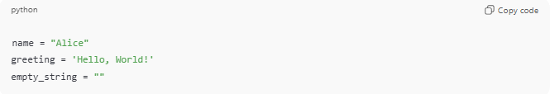
name = "Alice"
greeting = 'Hello, World!'
empty_string = ""
2. C
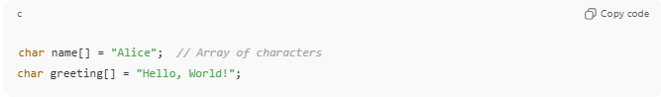
char name[] = "Alice"; // Array of characters
char greeting[] = "Hello, World!";
3. Java
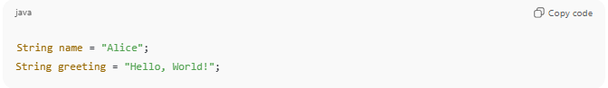
String name = "Alice";
String greeting = "Hello, World!";

Operations on Strings
# Source: AI Source: Provided by: [Data Path: Persons Table -> ID Column: 1, Name_En Column: Motasem Essam] -> From: [ChatGPT] on [1/26/2026]
- Concatenation: Joining strings together
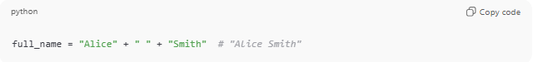
full_name = "Alice" + " " + "Smith" # "Alice Smith"
- Length: Number of characters in a string
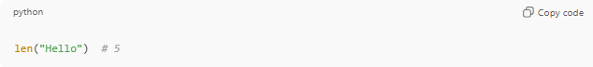
len("Hello") # 5
- Indexing: Access individual characters
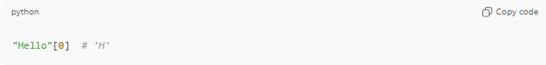
"Hello"[0] # 'H'
- Slicing/Substrings: Extract parts of a string
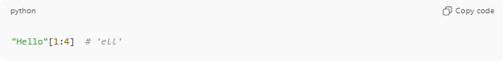
"Hello"[1:4] # 'ell'

Analogy
# Source: AI Source: Provided by: [Data Path: Persons Table -> ID Column: 1, Name_En Column: Motasem Essam] -> From: [ChatGPT] on [1/26/2026]
- String → A necklace
- Characters → Beads on the necklace
- Together, the beads (characters) form a complete string (necklace).

✅ Summary
# Source: AI Source: Provided by: [Data Path: Persons Table -> ID Column: 1, Name_En Column: Motasem Essam] -> From: [ChatGPT] on [1/26/2026]
- A string is a sequence of characters.
- Used to store text.
- Can be manipulated using operations like concatenation, slicing, and length.

